NAME: KAVYASHREE N

ROLL NO: 717821F225

WEEK 3 MINI PROJECT

HTML CODE:

<!DOCTYPE html>

<html lang="en">

<head>

    <meta charset="UTF-8">

    <meta name="viewport" content="width=device-width, initial-scale=1.0">

    <title>Task Scheduler</title>

    <link rel="stylesheet" href="scheduler.css">

</head>

<body>

    <div id="task-form">

        <input type="text" id="task-input" placeholder="Enter a task">

        <p>

        <button id="add-task">Add Task</button>

        </p>

    </div>

    <ul id="task-list"></ul>

</body>

<script src="scheduler.js"></script>

</html>

CSS CODE:

body {

    font-family: Arial, sans-serif;

    background-color: blue;

}

#task-form {

    margin-bottom: 20px;

}

#task-list {

    list-style: none;

    padding: 0;

}

.task {

    display: flex;

    justify-content: space-between;

    align-items: center;

    border: 1px solid #ccc;

    padding: 10px;

    margin-bottom: 5px;

}

.task button {

    background-color: red;

    color: white;

    border: none;

    cursor: pointer;

    background:black;

}

JS CODE:

const taskList = document.getElementById('task-list');

const taskInput = document.getElementById('task-input');

const addTaskButton = document.getElementById('add-task');

async function addTask() {

    const taskText = taskInput.value.trim();

    if (!taskText) return;

    const taskItem = document.createElement('li');

    taskItem.className = 'task';

    const taskTextElement = document.createElement('span');

    taskTextElement.textContent = taskText;

    const deleteButton = document.createElement('button');

    deleteButton.textContent = 'Delete';

    deleteButton.addEventListener('click', () => {

        taskItem.remove();

    });

    taskItem.appendChild(taskTextElement);

    taskItem.appendChild(deleteButton);

    taskList.appendChild(taskItem);

    taskInput.value = '';

    await simulateAsyncTask();

    console.log(`Task "${taskText}" added.`);

}

function simulateAsyncTask() {

    return new Promise(resolve => {

        setTimeout(resolve, 2000);

    });

}

addTaskButton.addEventListener('click', addTask);

SCREENSHOTS:

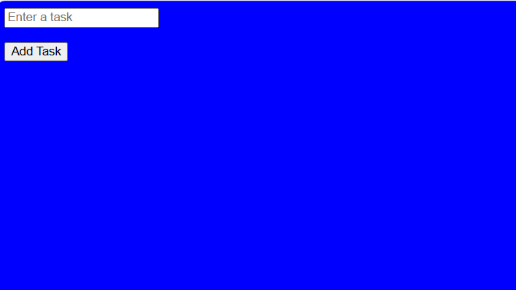

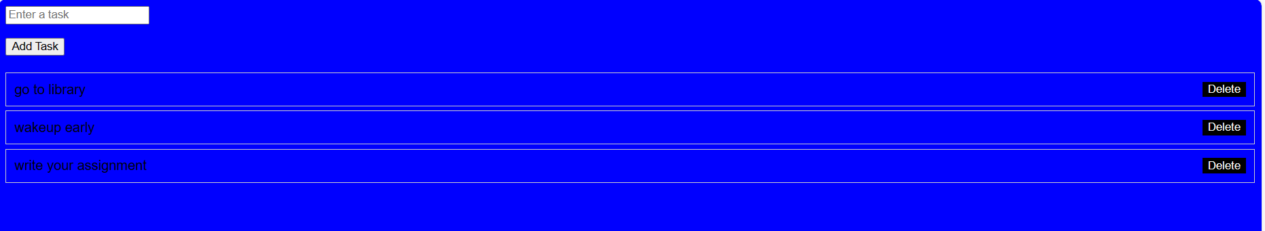

GITHUB LINK: